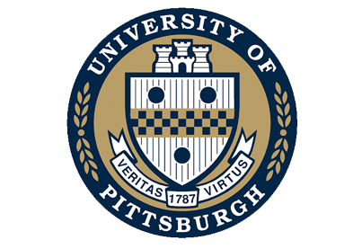

Office of Academic Career Development
Center for Doctoral and Postdoctoral Career Development

University of Pittsburgh
Suite 301 Scaife Hall
3550 Terrace Street
Pittsburgh, PA 15261
412-648-8486
Fax: 412-648-8121
Email: oacd@hs.pitt.edu

Trainee Career Options

Modify text as it applies to pre and/or postdoc training.

With regard to exposing predoctoral and postdoctoral trainees to career options, the University of Pittsburgh has introduced the Center for Doctoral and Postdoctoral Career Development (DPCD) and has instituted A Developmental Approach to Professional Training (ADAPTTM) in which career exploration and career specific development are integral components of this career development model.

Upon appointment to this training program, students will attend a 90 seminar, Introduction to Professional Development for Doctoral Students, where they will be oriented to this approach to professional career development, which is unique to the University of Pittsburgh. Postdoctoral trainees will attend an Orientation to Career Development specifically designed to equip them with the skills to successfully transition to their next career stage.

Throughout the year, the DPCD will host career panel discussions, career exploration workshops, and provide opportunities for students and postdocs to network with successful professionals in our regional workforce who are Pitt doctoral and postdoctoral alumni, among other activities intended to best prepare our trainees for successful and satisfying scientific careers in a wide range employment sectors upon the completion of their training.

